Diploma Programs in Europe: Undergraduate & Postgraduate Pathways with C3S Business School

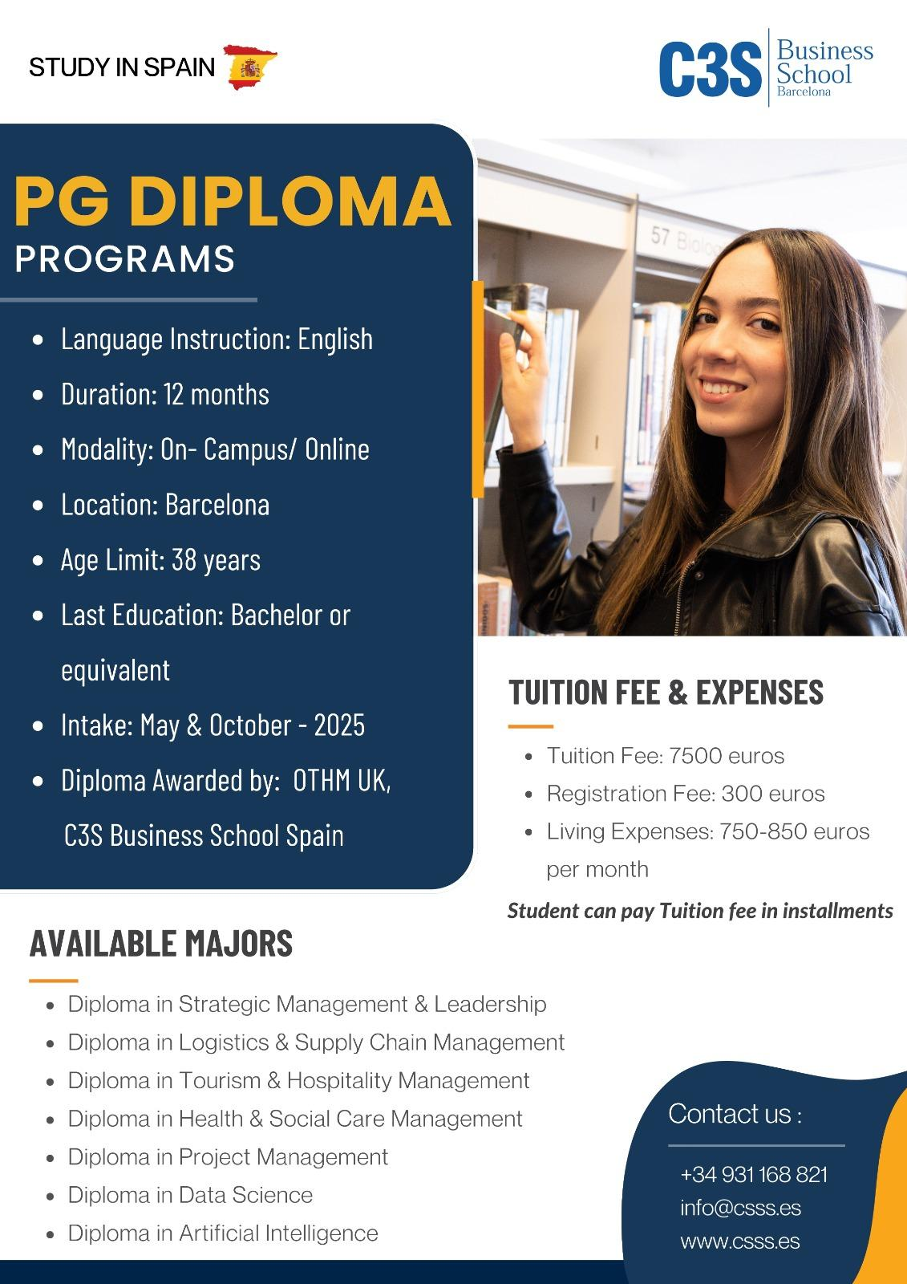 | 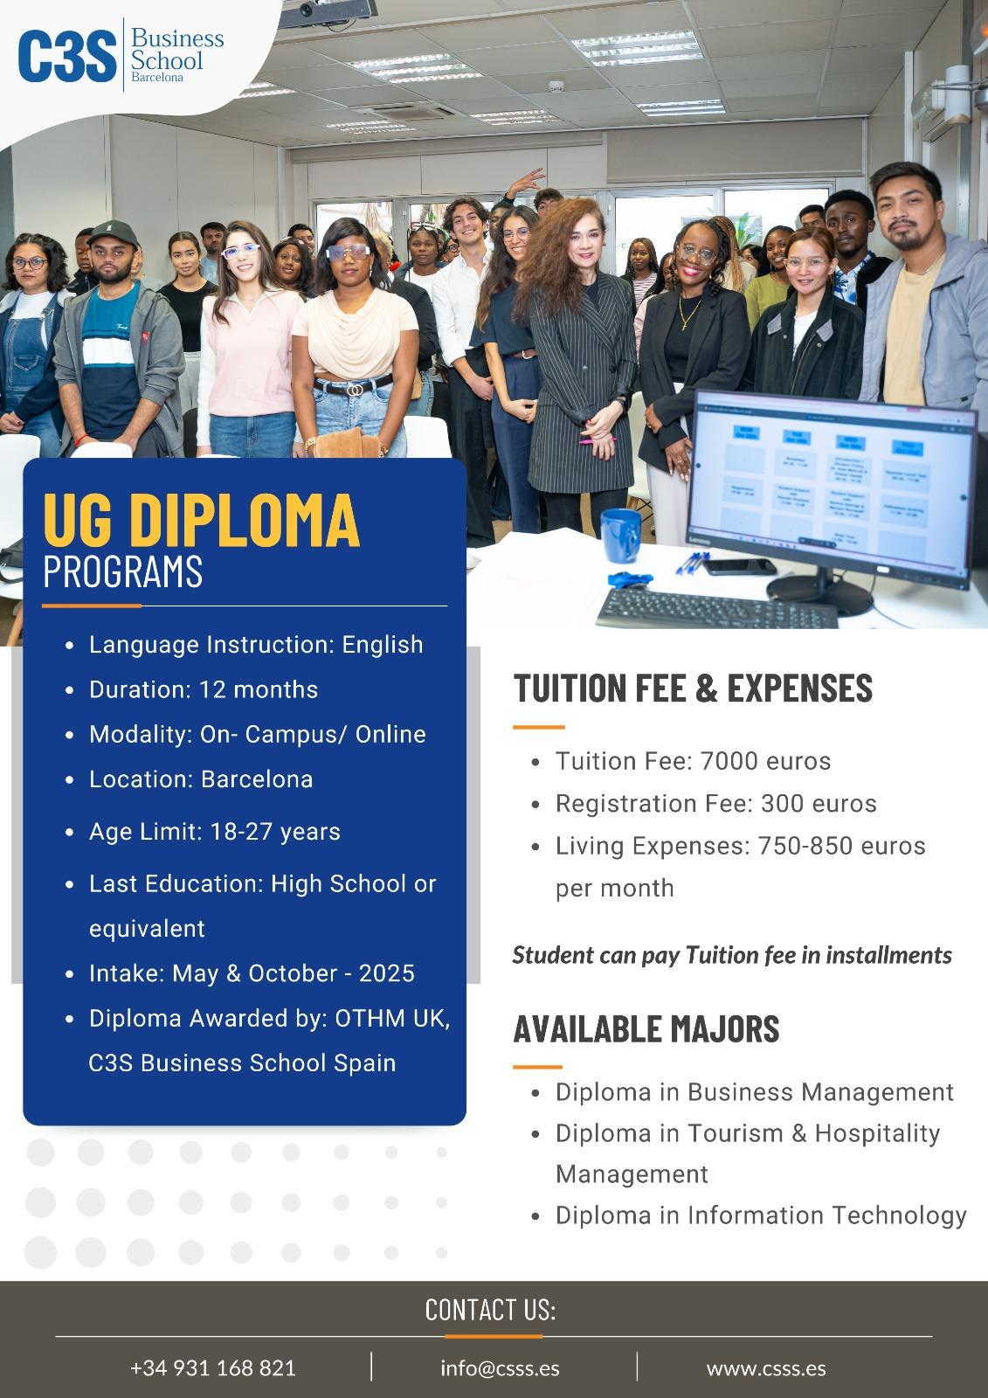

As global industries evolve rapidly, students and professionals are increasingly seeking practical, career-focused education that delivers results in a shorter timeframe. Diploma Programs in Europe offer exactly that: combining academic excellence, international exposure, and job-ready skills. At C3S Business School, we guide students toward the most suitable Undergraduate and Postgraduate Diploma Programmes in Europe, helping them build strong foundations or advance their careers on a global stage.

Why Choose Diploma Programs in Europe?

Europe is one of the world’s most attractive destinations for pursuing diploma studies. Here’s why:
- Internationally recognised qualifications
- Industry-oriented curriculum
- Shorter duration compared to degrees
- Affordable tuition options in many countries
- Opportunity to study and work part-time
- Multicultural learning environment

Diploma programs focus on real-world skills, making graduates more employable and confident in professional settings.

Undergraduate Diploma Programmes in Europe
What Is an Undergraduate Diploma?

An Undergraduate Diploma Programme is designed for students who have completed high school or equivalent education. These programs help students gain foundational knowledge and practical skills, serving as either a career-entry qualification or a pathway to further studies such as a bachelor’s degree.

Key Benefits of Undergraduate Diplomas

- Ideal for students starting their academic journey
- Strong focus on practical and applied learning
- Faster entry into the workforce
- Can lead to advanced standing in bachelor’s programmes

Popular Undergraduate Diploma Fields

- Diploma in Business Management
- Diploma in Tourism and Hospitality Management
- Diploma in Information Technology

Postgraduate Diploma Programmes in Europe

What Is a Postgraduate Diploma?
A Postgraduate Diploma Programme is designed for students who already hold a bachelor’s degree or have relevant professional experience. These programs focus on specialisation, career advancement, and leadership development.

Key Benefits of Postgraduate Diplomas
- Advanced, industry-relevant curriculum
- Shorter and more flexible than a master’s degree
- Ideal for career switching or upskilling
- Strong international recognition
- Excellent preparation for leadership roles

Popular Postgraduate Diploma Fields

- Diploma Project Management
- Diploma in Logistics and Supply Chain Management
- Diploma in Health and Social Care Management
- Diploma in Strategic Management and Leadership
- Diploma in Tourism and Hospitality Management
- Diploma in Accounting and Finance

How C3S Business School Supports Your European Diploma Journey

At C3S Business School, we offer personalised support every step of the way:

Program Selection: We help align your goals with the right diploma program, whether in Management, Finance, Marketing, or Entrepreneurship.

Application Assistance: From documentation to essay writing and interview prep, we simplify the process.

Visa & Logistics Support: Our experts guide you through visa applications, accommodation, and travel plans.

Scholarship & Funding Guidance: We help identify financial aid options that fit your budget and aspirations.

Career Benefits of a Diploma in Europe
A European diploma opens doors to exciting opportunities:
- Enhanced job prospects with global credentials
- Practical skills companies are actively seeking
- Professional networking across borders
- Pathway to further education or advanced certifications

