Valentine’s Day Gifting Guide at Mematgo

Thoughtful, Personalized & Romantic Gift Ideas from Mematgo

Introduction: Why Valentine’s Day Gifting Is So Special
Valentine’s Day is not just about exchanging gifts—it is about expressing love, appreciation, and emotional connection. Whether you are celebrating with your husband, wife, boyfriend, or girlfriend, the right gift can transform a simple moment into a lifelong memory.
In today’s digital age, couples prefer meaningful and personalized presents over generic items. This is why many shoppers now choose to buy customized gifts online from Mematgo. where emotions meet creativity through premium-quality, personalized gifting solutions.
This Valentine’s Day gifting guide will help you choose the perfect present based on relationship type, personality, and emotional intent.

Valentine Gift for Husband Online: Celebrate Love with Meaning
Choosing a valentine gift for husband online should reflect appreciation, companionship, and shared memories. Husbands often value gifts that are practical yet emotionally thoughtful.
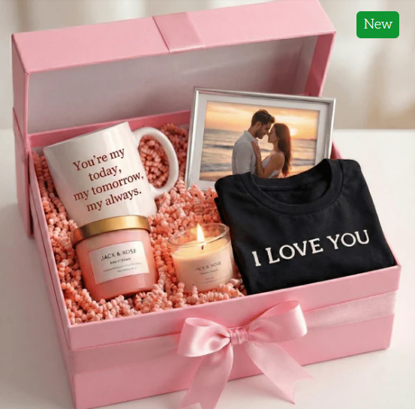

Best Valentine Gift Ideas for Husband:
- Personalized wallets with name engraving
- Customized mugs with romantic quotes
- Photo frames capturing special memories
- Personalized accessories for daily use
- Customized gift hampers curated for men
These gifts not only express love but also integrate seamlessly into everyday life, making them both meaningful and useful.

Order Unique Valentine Gift for Wife Online: Make Her Feel Special
Your wife deserves something that goes beyond ordinary gifting. When you order unique valentine gift for wife online, you show effort, thoughtfulness, and emotional depth.
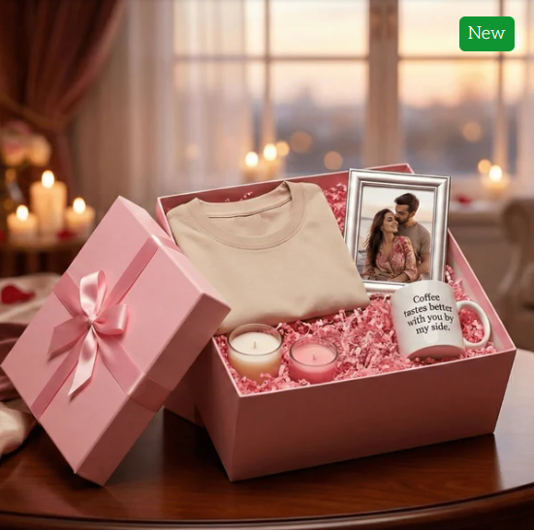

Popular Valentine Gifts for Wives:
- Personalized cushions with heartfelt messages
- Customized photo frames with couple moments
- Elegant gift hampers with multiple items
- Name-printed mugs or bottles
- Romantic wall décor with love quotes
Unique gifts create emotional resonance and remind your wife of how much she is valued, not just on Valentine’s Day but throughout the year.

Order Valentine Gift for Girlfriend: Romantic & Trendy Choices
For relationships filled with excitement and youthful energy, choosing the right gift matters. When you order valentine gift for girlfriend, personalization plays a key role in making the gift unforgettable.

Ideal Valentine Gift Ideas for Girlfriend:
- Customized teddy bears or cushions
- Personalized jewelry boxes
- Couple photo frames
- Matching couple accessories
- Creative personalized hampers
These gifts are perfect for expressing affection while celebrating individuality and shared memories.

Valentine Gift for Boyfriend Online: Practical Yet Emotional
Shopping for a valentine gift for boyfriend online is easier when you combine practicality with emotion. Men often appreciate gifts they can use daily while still feeling emotionally connected.

Trending Valentine Gifts for Boyfriends:
- Personalized keychains or wallets
- Customized mugs for work or home
- Photo frames with memorable moments
- Customized t-shirts with subtle designs
- Personalized gift hampers
Such gifts strike the perfect balance between utility and romance.

Customized Gift for Couples Online: Perfect for Shared Celebrations
Couple gifting has evolved into a powerful way of celebrating togetherness. A customized gift for couples online allows both partners to feel equally valued.

Popular Customized Couple Gifts:
- Matching couple mugs
- His & her cushions
- Personalized couple t-shirts
- Name-engraved photo frames
- Couple keychains or accessories
These gifts are ideal not just for Valentine’s Day, but also for anniversaries, engagements, and special milestones.

Why Personalized Gifts Are the Best Choice for Valentine’s Day
Personalization adds emotional depth to gifting. Instead of buying generic items, couples now prefer gifts that tell their story.

Benefits of Personalized Valentine Gifts:
- Creates emotional connection
- Shows extra effort and thought
- Feels exclusive and memorable
- Suitable for long-term use
- Strengthens relationship bonds
This is why many customers choose to buy customized gifts online from Mematgo for Valentine’s Day celebrations.
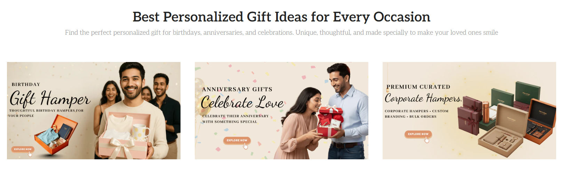

Valentine Gift Hampers: One Gift, Many Emotions
Gift hampers combine multiple thoughtful items into one beautifully presented package. They are ideal for customers who want variety without confusion.

What Valentine Gift Hampers Usually Include:
- Customized mugs or cushions
- Greeting cards with messages
- Photo frames
- Accessories or décor items
- Elegant packaging
Hampers are suitable for husbands, wives, girlfriends, and boyfriends alike.

Long-Distance Valentine Gifting Made Easy
For couples in long-distance relationships, Valentine’s Day becomes emotionally significant. Personalized gifts help bridge the physical gap.

Best Long-Distance Valentine Gift Ideas:
- Photo cushions with messages
- Personalized frames delivered to doorstep
- Customized mugs for daily reminders
- Memory boxes
- Couple accessories
With online gifting options, it becomes easy to send love across cities and states.

Budget-Friendly Valentine Gifts with Premium Feel
Meaningful gifting does not require a large budget. Mematgo offers a wide range of affordable yet premium-looking gifts.

Affordable Valentine Gift Options:
- Name-printed mugs
- Customized keychains
- Photo frames
- Printed notebooks
- Personalized bottles
These options are perfect for first-time gift exchanges or budget-conscious shoppers.

Valentine Gifting for Married Couples
Married couples often look for gifts that celebrate companionship and shared life experiences.

Ideal Gifts for Married Couples:
- Customized couple cushions
- Photo frames with wedding memories
- Personalized décor items
- Matching accessories
- Couple gift hampers
Choosing a customized gift for couples online helps celebrate love in a mature and meaningful way.

How to Choose the Right Valentine Gift
Selecting the perfect Valentine’s gift requires clarity and planning.

Step-by-Step Guide:
- Identify the recipient (husband, wife, boyfriend, girlfriend)
- Decide between emotional or practical gifting
- Choose personalization options
- Set a realistic budget
- Order early to ensure timely delivery
This approach ensures a smooth and satisfying gifting experience.

Why Mematgo Is Trusted for Valentine Gifting
Mematgo has built a reputation for quality, creativity, and customer satisfaction.

Key Reasons to Choose Mematgo:
- Premium-quality materials
- Easy customization process
- Wide variety of Valentine gifts
- Thoughtful designs for couples
- Reliable customer support
Customers who buy customized gifts online from Mematgo receive value, emotion, and quality in every order.

Valentine’s Day Beyond Romance: Celebrating Love in All Forms
Valentine’s Day gifting is not limited to romantic partners. It is also a great occasion to celebrate love between:
- Married couples
- Engaged couples
- Long-term partners
- Newlyweds
The same customized gift for couples online applies beautifully across all relationship stages.

Final Thoughts: Make This Valentine’s Day Truly Memorable
Valentine’s Day is about creating moments that last beyond the celebration. Whether you choose a valentine gift for husband online, order unique valentine gift for wife online, order valentine gift for girlfriend, or select a valentine gift for boyfriend online, personalization ensures your emotions are felt deeply.
With Mematgo, gifting becomes easy, meaningful, and memorable. From romantic keepsakes to practical personalized items, every product is designed to strengthen emotional bonds.
Explore Valentine’s gifts here:
https://www.mematgo.com/collections/valentines-day-gifts
Explore couple gifts here:
https://www.mematgo.com/collections/couples-gifts
Shop personalized gifts at:
https://www.mematgo.com/

Contact Details
Website: https://www.mematgo.com/
Mobile: +91 9715714714
Email: mematgo@gmail.com
Thank You

