Master Program in Spain at C3S Business School — Your Gateway to Global Business Leadership

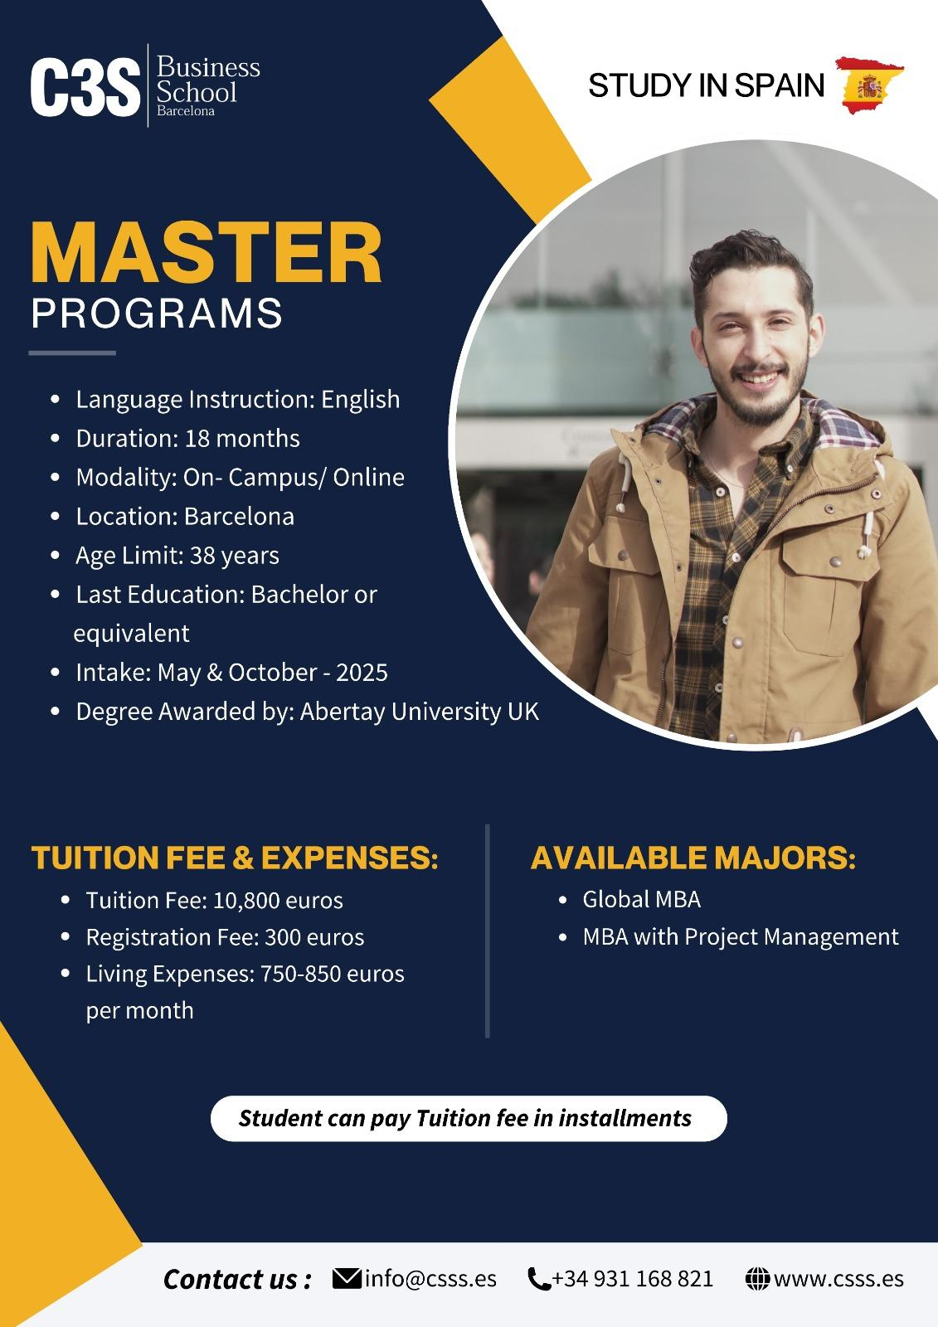
Dreaming of a Master Program in Spain that blends academic excellence with real-world business skills? The top business school in Spain offers dynamic and globally oriented Master’s and MBA programs designed to prepare tomorrow’s leaders for success in international business.

Why Choose C3S Business School for Your Master
C3S Business School (Castelldefels School of Social Sciences) is a fully accredited private institution registered with the Spanish Ministry of Education, and it proudly welcomes students from around the world. Instruction is delivered entirely in English, making it accessible to international learners without the need for prior Spanish language skills (though Spanish classes are offered to help with cultural integration).
Here’s what makes C3S stand out:
Internationally focused curriculum with a blend of theory and hands-on practice.
Small class sizes for personalized learning and deeper engagement.
Modern blended teaching methods combine in-class sessions with e-learning.
Access to career support, internships, and networking opportunities within Barcelona’s global business environment.
Barcelona itself is a thriving hub for entrepreneurship, technology, and culture; an ideal setting for academic and professional growth.

Master’s Programs Offered

Global MBA — Leadership for a Globalized World
The Global MBA program equips students with comprehensive management and leadership skills tailored to international business environments. This degree focuses on strategic thinking, financial decision-making, people leadership, and cross-cultural business skills — ideal for those targeting global managerial roles. Students can leverage their MBA as a springboard to doctoral studies, enter senior global management positions, or launch entrepreneurial ventures with confidence.

MBA with Project Management — Master Complex Business Challenges
This MBA specialization focuses on both business strategy and the essentials of project management — a combination highly valued in today’s workplace. Students learn how to lead teams, manage organizational change, and deliver complex projects under real business conditions. The program offers flexible delivery options, including on-campus and online components, catering to working professionals and international students alike.

Innovative Teaching for Real-World Skills
At C3S, learning goes beyond traditional lectures. The school adopts modern pedagogical approaches that develop critical thinking, problem-solving, and creativity — skills essential for leadership in a rapidly changing global economy.
Students engage in activities such as:
- Collaborative group work and case studies
- Inquiry-based research projects
- Problem-based learning rooted in real-world business scenarios
- Reflective exercises that enhance emotional intelligence and leadership awareness
This blended approach ensures that graduates are not only theoretically informed but also industry-ready, capable of solving complex challenges from the outset.

Who Should Apply?
C3S Master’s programs are ideal if you are: A recent graduate seeking advanced qualifications in international business.
- A working professional aiming to pivot into leadership or specialize in project management.
- An international student looking for an English-taught degree in one of Europe’s most dynamic cities

Key Benefits of Studying at C3S
Global Recognition – UK-accredited degrees are awarded in partnership with recognized awarding bodies, enhancing worldwide employability.
English-Taught Programs – No Spanish required, though opportunities to learn the language are available.
Practical Experience – Internships, industry projects, and professional networking.
Cultural & Professional Immersion – Study in Barcelona, a cosmopolitan European business gateway.

Wrapping Up
Choosing to pursue a Master’s at C3S Business School in Spain is more than an academic decision — it’s an investment in your global career. With its practical curriculum, international learning environment, and career-focused support, C3S equips you with the tools to succeed in a competitive business landscape. Whether your ambition is to lead international teams, launch your own venture, or specialize in strategic project management, C3S offers the knowledge, skills, and global perspective to help you reach your goals.

