The Complete Guide to Personalized Wallets, Couple Gifts, and Customized Diary Sets
In today’s gifting landscape, personalization is no longer a luxury—it is an expectation. People want gifts that reflect thought, intention, and emotional intelligence. Whether you are celebrating a birthday, anniversary, wedding, corporate milestone, or festive occasion, customized gifts create a stronger emotional connection than generic items ever could.
This comprehensive guide explores three highly popular and meaningful gifting categories: personalized wallets, couple gifts, and customized diary sets. Each of these options combines practicality with sentiment, making them ideal for both personal and professional occasions.

Why Personalized Gifting Is the Future
Gifting has evolved significantly over the past decade. Earlier, price and brand name dominated purchase decisions. Today, meaning matters more. A thoughtfully selected customized product communicates effort, understanding, and emotional awareness.
Personalized gifts:
- Reflect individual identity
- Create lasting keepsakes
- Strengthen relationships
- Increase perceived value
- Offer everyday usability with sentimental attachment
When you personalize an item, you transform it from a product into a memory.

Section 1: The Timeless Appeal of Personalized Wallets
Wallets are among the most practical accessories a person uses daily. Because they are handled frequently, they offer a constant reminder of the person who gifted them. This makes them an exceptional personalization opportunity.

The Rising Demand for custom wallets for men
Modern men appreciate accessories that combine functionality with style. custom wallets for men have gained popularity because they allow subtle personalization without compromising elegance. Adding a name, initials, or a meaningful date enhances emotional value while maintaining a sophisticated aesthetic.
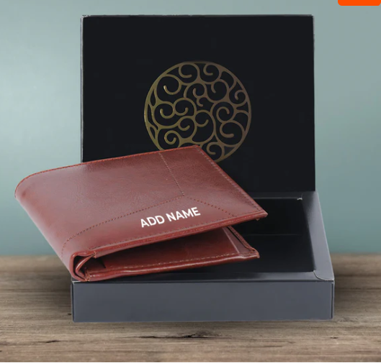
These wallets are ideal for:
- Birthdays
- Anniversaries
- Groom gifts
- Corporate gifting
- Father’s Day
- Milestone celebrations
High-quality materials such as genuine leather, premium vegan leather, and durable stitching ensure longevity. When personalization is done through embossing or engraving, it adds a refined finish that enhances perceived value.

Why a wallet for men with name Makes a Meaningful Gift
A wallet for men with name is not just an accessory—it becomes personal property marked with identity. Unlike mass-produced items, a named wallet conveys exclusivity.
Psychologically, people feel stronger attachment to items bearing their name. This increases long-term retention and emotional connection to the gift.
It is especially popular for:
- Husbands
- Fathers
- Brothers
- Best friends
- Groomsmen
Minimalist design paired with subtle personalization strikes the perfect balance between utility and sentiment.

The Emotional Value of personalized wallets for men
When gifting personalized wallets for men, the key is thoughtful customization rather than over-decoration. A clean font, carefully chosen placement, and quality craftsmanship ensure the wallet remains elegant.
Benefits include:
- Daily usage ensures visibility
- Strong durability offers long-term value
- Compact yet impactful gifting option
- Suitable for all age groups
A well-designed personalized wallet often becomes a long-term keepsake.

Section 2: Celebrating Togetherness with Couple Gifts
Relationships thrive on shared experiences. Gifts that celebrate unity and partnership carry deeper meaning than individual items.

The Growing Popularity of custom couple Gifts
Personalized gifting for couples has expanded beyond traditional photo frames. Today, custom couple Gifts include coordinated accessories, matching items, engraved keepsakes, and thoughtful daily-use products.
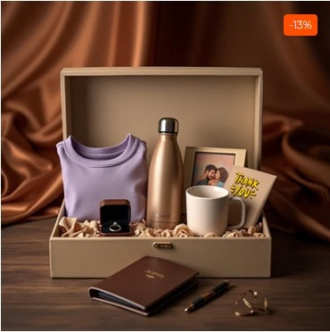
These gifts are ideal for:
- Weddings
- Anniversaries
- Engagements
- Valentine’s Day
- Newlywed celebrations
Customization allows you to incorporate names, special dates, or even meaningful quotes that reflect the couple’s journey.

Why personalized couple gifts Strengthen Emotional Bonds
Thoughtfully curated personalized couple gifts symbolize unity. They celebrate shared milestones and reflect the strength of partnership.
Effective couple gifting strategies include:
- Complementary designs
- Shared theme aesthetics
- Balanced personalization
- Elegant packaging
The key principle is harmony. Both recipients should feel equally valued in the customization.
When designed well, couple gifts become treasured keepsakes that mark a chapter in their shared story.

Section 3: The Return of Elegant Stationery Gifting
In a digital age dominated by screens, physical stationery has regained significance. Diaries represent intention, discipline, creativity, and reflection. Adding personalization elevates them further.

The Versatility of a customized diary
A customized diary is suitable for students, professionals, entrepreneurs, writers, and planners. It serves as:
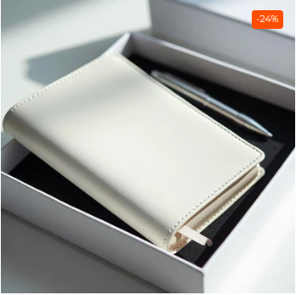
- A journal
- A business planner
- A gratitude notebook
- A creative idea book
Personalization transforms it into a signature possession.

Why Choose a customized diary with name
Adding a name creates ownership. A customized diary with name signals exclusivity and personal identity.
This is especially popular for:
- Corporate gifting
- Employee appreciation
- Graduation gifts
- Teacher gifts
- Business professionals
Clean typography and premium cover materials enhance sophistication.

Combining Utility with Elegance: customized diary and pen
A customized diary and pen combination elevates gifting to a professional level. The pairing ensures usability while maintaining aesthetic appeal.
This is ideal for:
- Conferences
- Corporate welcome kits
- Executive gifting
- Milestone recognition
The pen, when engraved, complements the diary’s personalization and enhances the gift’s overall value.

The Sophistication of a diary and pen gift set
Presentation matters. A diary and pen gift set packaged in a premium box conveys refinement and thoughtfulness.
Gift sets are preferred because they:
- Feel complete
- Enhance perceived luxury
- Simplify gift selection
- Offer cohesive design
High-quality packaging increases the overall gifting experience.

The Elegance of a personalised diary and pen set
For recipients who appreciate refined details, a personalised diary and pen set represents sophistication and practicality.
It is especially effective for:
- Business executives
- Wedding return gifts
- Premium festive gifting
- Corporate events
The combination of usability and personalization ensures long-term relevance.

How to Choose the Right Personalized Gift
When selecting a customized gift, consider:
- The recipient’s personality
- The occasion
- Long-term usability
- Quality of material
- Subtlety of personalization
Avoid over-customization. Minimal and elegant personalization tends to have stronger long-term appeal.

Material and Craftsmanship Considerations
Quality directly impacts perception. Premium leather, durable stitching, strong binding, and high-quality engraving techniques ensure longevity.
Key factors include:
- Scratch resistance
- Long-lasting embossing
- Premium paper quality
- Secure packaging
- Clean finishing
A well-crafted personalized item enhances brand credibility and customer satisfaction.

Personalized Gifting for Corporate Clients
Businesses increasingly prefer personalized gifting to strengthen professional relationships. Customized wallets and diary sets are widely used in:
- Employee onboarding
- Annual appreciation events
- Client relationship management
- Event giveaways
- Festive gifting campaigns
Adding subtle branding alongside personalization can elevate impact.

Emotional Psychology Behind Personalization
Research shows people develop stronger attachments to items that reflect their identity. Personalization creates a sense of ownership and uniqueness.
This psychological principle explains why customized gifts:
- Are retained longer
- Are rarely discarded
- Generate positive emotional recall
- Strengthen interpersonal bonds
When you give a personalized product, you are not just gifting an object—you are gifting recognition.

Packaging: The Silent Influencer
Elegant packaging enhances perceived value. Premium gift boxes, magnetic closures, protective wrapping, and clean branding elevate the unboxing experience.
Presentation can significantly influence how the recipient emotionally perceives the gift.

The Long-Term Value of Thoughtful Gifting
Unlike trend-based products, personalized accessories and stationery remain relevant for years. Their practicality ensures daily interaction, reinforcing emotional significance over time.
When selected thoughtfully, these gifts:
- Build deeper relationships
- Reflect attention to detail
- Offer daily functionality
- Create memorable impressions

Final Thoughts
Personalized gifting bridges the gap between practicality and emotion. Whether you choose a wallet, a couple gift, or an elegant diary set, the key lies in quality, subtle customization, and thoughtful presentation.
A well-personalized gift does more than celebrate an occasion—it becomes part of someone’s everyday life.

Contact Details
For premium personalized gifting solutions, bulk orders, or custom design assistance, feel free to contact:
📞 Phone: +91 9715714714
📧 Email: order@mematgo.com
🌐 Website: https://www.mematgo.com
We are happy to assist you in selecting the perfect personalized gift that reflects thought, quality, and lasting emotional value.

