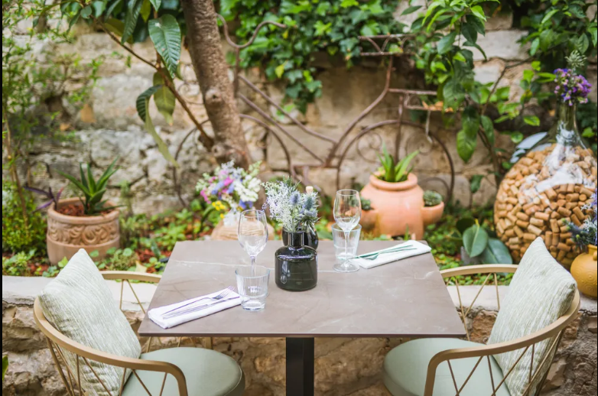

Restaurant Hvar: A Complete Guide to Fine Dining and Local Cuisine on Croatia's Famous Island
When travelers think about Croatia's most attractive island destinations, Hvar is often at the top of the list. Known for its sunny climate, historic architecture, beautiful beaches, and vibrant nightlife, the island is also a paradise for food lovers. Choosing the right Restaurant Hvar experience allows visitors to enjoy authentic Croatian flavors while surrounded by breathtaking Adriatic scenery.
From waterfront dining venues to charming family-owned establishments hidden in ancient stone streets, Restaurant Hvar options offer a perfect blend of traditional recipes and modern culinary creativity. Every meal tells a story of local culture, fresh ingredients, and Mediterranean hospitality.

The Rich Culinary Heritage of Hvar
The cuisine found at a Restaurant Hvar location is heavily influenced by centuries of Mediterranean traditions. The island's strategic position along important maritime routes introduced a variety of culinary techniques and ingredients that continue to shape local food culture today.
Fresh seafood, olive oil, locally grown vegetables, aromatic herbs, and premium wines form the foundation of many dishes. Chefs take pride in preserving traditional recipes while introducing contemporary elements that appeal to international visitors.
As a result, Restaurant Hvar establishments provide dining experiences that are both authentic and innovative.

Fresh Ingredients Make the Difference
One reason why visitors consistently praise Restaurant Hvar dining is the exceptional quality of ingredients. Local fishermen supply restaurants with daily catches from the Adriatic Sea, ensuring maximum freshness.
Seasonal vegetables are harvested from nearby farms, while olive groves produce high-quality olive oil used in countless dishes. These ingredients contribute to rich flavors and healthy Mediterranean meals.
Many Restaurant Hvar menus change seasonally to reflect ingredient availability, allowing guests to enjoy the freshest produce and seafood throughout the year.

Popular Seafood Specialties
Seafood plays a central role in the Hvar dining experience. Guests visiting a Restaurant Hvar venue can choose from a wide variety of expertly prepared seafood dishes.
Grilled sea bass, sea bream, octopus, squid, shrimp, and lobster are among the most sought-after menu items. These dishes are often served with locally grown vegetables, fresh salads, and homemade bread.
Seafood risotto is another favorite among visitors. Prepared with fresh shellfish and rich Mediterranean seasonings, it perfectly captures the flavors of the Adriatic region.
For seafood enthusiasts, Restaurant Hvar dining provides endless opportunities to explore new and exciting flavors.

Traditional Croatian Dishes Worth Trying
While seafood is a highlight, Restaurant Hvar menus also feature traditional Croatian dishes that showcase the island's heritage.
Peka remains one of the most famous local specialties. This slow-cooked dish combines meat or seafood with potatoes and vegetables, creating a flavorful and satisfying meal.
Lamb dishes are also popular, especially those prepared using traditional island cooking methods. Many restaurants serve homemade pasta, local cheeses, cured meats, and fresh bread as part of their authentic Croatian offerings.
These traditional meals allow visitors to experience the true essence of Hvar's culinary culture.

Waterfront Dining Experiences
One of the most appealing aspects of Restaurant Hvar dining is the stunning setting. Numerous restaurants are located directly along the waterfront, providing unforgettable views of the Adriatic Sea.
Guests can enjoy lunch while watching luxury yachts arrive in the harbor or savor a romantic dinner during a spectacular sunset. The combination of exceptional food and beautiful surroundings creates a memorable dining atmosphere.
Many Restaurant Hvar venues feature outdoor terraces where guests can relax and enjoy the island's pleasant Mediterranean climate throughout much of the year.

Local Wines and Gastronomic Pairings
Wine production has been part of Hvar's history for generations. Today, Restaurant Hvar establishments proudly serve regional wines that perfectly complement local cuisine.
White wines pair beautifully with seafood dishes, while red wines enhance grilled meats and traditional Croatian specialties. Experienced staff often recommend pairings that elevate the overall dining experience.
Many restaurants also offer wine-tasting opportunities, allowing visitors to discover the unique characteristics of locally produced varieties.

Perfect for Every Occasion
Whether planning a romantic evening, family celebration, business dinner, or casual lunch, Restaurant Hvar options cater to every type of gathering.
Upscale restaurants provide elegant settings and gourmet menus, while smaller family-owned establishments deliver warm hospitality and traditional home-style cooking. This diversity ensures that every visitor can find a restaurant that matches their preferences and budget.
Many Restaurant Hvar venues also accommodate larger groups and special events, making them popular choices for celebrations and private gatherings.

Why Food Lovers Choose Restaurant Hvar
Food enthusiasts from around the world visit Hvar specifically to explore its remarkable culinary scene. The combination of fresh ingredients, skilled chefs, traditional recipes, and scenic locations makes Restaurant Hvar a standout destination for dining.
Each restaurant offers its own unique interpretation of Mediterranean cuisine while maintaining a strong connection to local traditions. This balance between authenticity and creativity keeps visitors returning year after year.

Conclusion
A trip to Hvar Island is not complete without experiencing the incredible food culture that defines the region. Every Restaurant Hvar venue offers guests the opportunity to enjoy fresh seafood, traditional Croatian specialties, premium local wines, and unforgettable waterfront views.
Whether you are seeking fine dining, authentic local cuisine, or a relaxing meal beside the sea, Restaurant Hvar establishments deliver exceptional experiences that showcase the very best of Croatia's Adriatic coast. For travelers who appreciate outstanding food and remarkable hospitality, Hvar remains one of the most rewarding culinary destinations in Europe.

