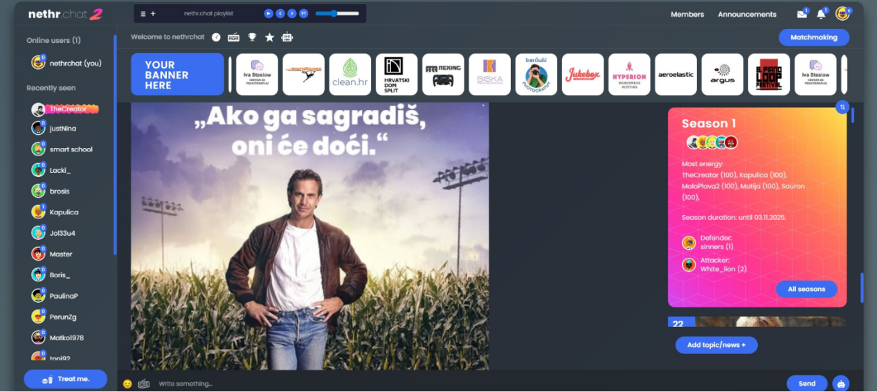

Hrvatski Chat: Connecting People Through Online Conversations

Introduction
The internet has transformed the way people communicate, making it easier than ever to connect with others regardless of location. Among the many communication tools available today, Hrvatski Chat has become a popular choice for individuals who want to engage in conversations in the Croatian language. Whether you are looking to make new friends, participate in discussions, or simply enjoy casual conversations, Hrvatski Chat provides an accessible platform for users of all ages.
As digital communication continues to evolve, online chat communities remain an important part of social interaction. Hrvatski Chat offers a space where people can exchange ideas, share experiences, and build meaningful connections in a friendly environment.

What Is Hrvatski Chat?
Hrvatski Chat refers to online chat platforms designed for Croatian-speaking users. These platforms allow people to communicate through real-time text messaging, creating opportunities for interaction and networking. Users can join public chat rooms, participate in group discussions, or engage in private conversations based on their interests.
Unlike traditional social media platforms that focus heavily on content sharing, Hrvatski Chat emphasizes direct communication. This makes it an ideal choice for individuals who enjoy engaging conversations and instant interaction.

Why Is Hrvatski Chat Popular?

Easy Communication
One of the biggest advantages of Hrvatski Chat is its simplicity. Users can quickly join conversations without needing extensive technical knowledge. Most chat platforms are user-friendly and accessible from both computers and mobile devices.
This convenience allows people to stay connected anytime and anywhere, making communication more efficient than ever before.

Meeting New People
Many users join Hrvatski Chat to expand their social circles. The platform brings together people from different cities, regions, and even countries. Croatian speakers living abroad often use these chat communities to stay connected with their language and culture.
Through regular conversations, users can develop friendships, exchange ideas, and learn about different perspectives.

Sharing Common Interests
Hrvatski Chat often includes themed chat rooms where users can discuss topics such as sports, technology, travel, education, entertainment, and culture. These dedicated spaces make it easier for people with similar interests to find each other and engage in meaningful discussions.
The ability to connect through shared interests helps create stronger and more enjoyable online communities.

Benefits of Using Hrvatski Chat

Real-Time Interaction
Unlike emails or forum posts that may require waiting for responses, Hrvatski Chat provides instant communication. Real-time messaging allows conversations to flow naturally and keeps users actively engaged.
This immediate interaction creates a more personal and dynamic communication experience.

Language Practice
For people learning Croatian, Hrvatski Chat can serve as a valuable language-learning tool. By communicating with native speakers, learners can improve their vocabulary, grammar, and conversational skills in a practical setting.
Regular interaction helps users gain confidence while developing their language abilities.

Community Building
Online communities play an important role in modern society. Hrvatski Chat enables users to become part of active groups where they can exchange knowledge, provide support, and build lasting relationships.
These communities often foster a sense of belonging and encourage positive social interaction.

Staying Safe While Using Hrvatski Chat
Online safety should always be a priority when participating in chat platforms. Although most users have positive experiences, following basic safety guidelines can help protect personal information.
Some important tips include:
- Avoid sharing sensitive personal details.
- Use strong and secure passwords.
- Be cautious when communicating with strangers.
- Report inappropriate behavior to moderators.
- Respect community rules and guidelines.
Responsible use of Hrvatski Chat contributes to a safer and more enjoyable experience for everyone.

Features Commonly Found in Hrvatski Chat Platforms
Modern chat platforms continue to evolve and offer a variety of useful features. Depending on the service, users may have access to:

Private Messaging
Private conversations allow users to communicate one-on-one without participating in public discussions.

Group Chat Rooms
Group chat rooms provide spaces for larger conversations where multiple users can interact at the same time.

Mobile Accessibility
Many Hrvatski Chat platforms are optimized for smartphones and tablets, allowing users to stay connected wherever they go.

User Profiles
Profiles help users introduce themselves and share basic information about their interests, making it easier to connect with like-minded individuals.

The Future of Hrvatski Chat
Technology continues to shape how people communicate online. New developments in messaging systems, artificial intelligence, and security measures are improving the overall chat experience.
Future versions of Hrvatski Chat may include enhanced personalization, smarter moderation systems, and improved communication tools. These advancements will help create more engaging and secure environments for users.
As internet access expands globally, the popularity of online chat communities is expected to continue growing. Hrvatski Chat will likely remain an important platform for Croatian-speaking users seeking meaningful conversations and social connections.

Conclusion
Hrvatski Chat is an excellent platform for people who enjoy online communication in the Croatian language. It offers opportunities to meet new people, participate in interesting discussions, and stay connected with a broader community.
Whether you are looking for friendship, cultural exchange, language practice, or casual conversation, Hrvatski Chat provides a welcoming environment for interaction. As technology continues to advance, these online communities will remain valuable spaces for communication, learning, and relationship building in the digital age.

