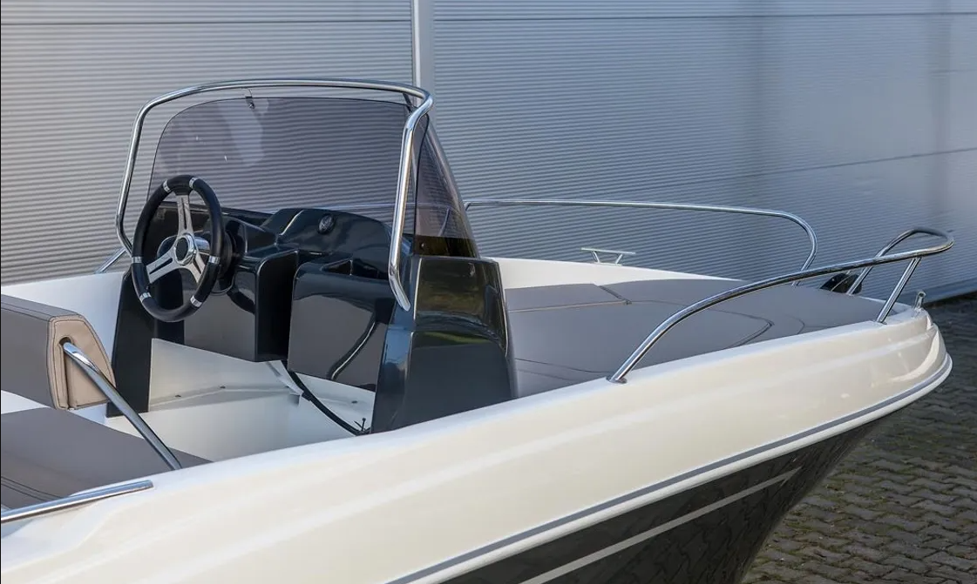

Boat Rental Lumbarda – Discover the Beauty of Korčula from the Sea
Lumbarda is one of the most beautiful coastal destinations on Korčula Island, Croatia. Known for its sandy beaches, crystal-clear Adriatic waters, and picturesque landscapes, Lumbarda attracts visitors looking for relaxation and adventure. One of the best ways to experience the region is through a boat rental Lumbarda, giving you the freedom to explore hidden coves, nearby islands, and stunning coastal scenery at your own pace.
Whether you are planning a romantic getaway, a family vacation, or an exciting day with friends, renting a boat provides a unique opportunity to discover places that are difficult to reach by land. From secluded beaches to charming fishing villages, every journey becomes a memorable adventure.

Why Choose Boat Rental in Lumbarda?
A boat rental offers flexibility and convenience that traditional tours cannot match. Instead of following a fixed schedule, you can create your own itinerary and spend as much time as you like at each destination.
Benefits of renting a boat in Lumbarda include:
- Explore hidden beaches and quiet bays
- Visit nearby islands and coastal attractions
- Enjoy swimming and snorkeling in clear waters
- Experience breathtaking sunsets from the sea
- Create a personalized travel experience
- Avoid crowded tourist areas
- Perfect for couples, families, and groups

Explore the Stunning Korčula Archipelago
The waters surrounding Lumbarda are filled with beautiful islands and natural attractions. With a rental boat, you can easily reach some of the most spectacular locations in the region.

Vrnik Island
Vrnik is a peaceful island famous for its stone quarries and traditional Mediterranean atmosphere. Visitors can enjoy swimming, walking trails, and local restaurants serving fresh seafood.

Badija Island
Badija is known for its historic monastery, scenic beaches, and friendly deer that roam freely across the island. It is a perfect destination for a relaxing day trip.

Korčula Old Town
Arriving by boat provides a unique perspective of Korčula Old Town. The medieval architecture, narrow streets, and waterfront cafés make it one of Croatia’s most impressive historic destinations.

Hidden Bays and Beaches
Many secluded beaches around Lumbarda can only be accessed by boat. These peaceful locations provide ideal conditions for swimming, sunbathing, and snorkeling away from busy tourist areas.

Boat Rental Options Available
Visitors can choose from a variety of boats depending on their preferences and experience level.

Motorboats
Motorboats are perfect for exploring multiple destinations quickly and comfortably.

Family Boats
Larger boats provide extra space, making them ideal for family outings and group excursions.

Luxury Boat Rentals
Luxury vessels offer premium comfort, stylish interiors, and enhanced amenities for a memorable day on the water.

Self-Drive Boat Rentals
Many providers offer boats that can be operated without extensive boating experience, allowing visitors to enjoy independent exploration.

Activities to Enjoy During Your Boat Adventure
A boat rental in Lumbarda opens the door to numerous activities and unforgettable experiences.

Swimming
The Adriatic Sea offers exceptionally clear waters, perfect for refreshing swims.

Snorkeling
Discover underwater life, colorful fish, and fascinating marine habitats.

Island Hopping
Visit several islands in a single day and experience the diversity of the Korčula archipelago.

Photography
Capture stunning coastal landscapes, historic landmarks, and beautiful sunsets.

Relaxation
Anchor in a peaceful bay and enjoy the tranquility of the sea surrounded by natural beauty.

Tips for Renting a Boat in Lumbarda
To ensure a safe and enjoyable experience, consider the following tips:
- Book your boat in advance during peak season
- Check weather conditions before departure
- Bring sunscreen, water, and snacks
- Follow local boating regulations
- Carry a charged mobile phone
- Plan your route before leaving the harbor
- Respect marine life and protected areas

Why Tourists Love Lumbarda
Lumbarda combines authentic Croatian charm with spectacular coastal scenery. The village offers a relaxed atmosphere while providing easy access to some of the Adriatic's most beautiful locations. Boat rentals allow visitors to experience the region from a completely different perspective, creating unforgettable memories on the water.
From hidden beaches and crystal-clear bays to historic towns and nearby islands, every journey offers something unique. Whether you are seeking adventure, relaxation, or exploration, a boat rental in Lumbarda is one of the best ways to experience everything this stunning destination has to offer.

Book Your Boat Rental in Lumbarda Today
Experience the freedom of the Adriatic Sea with a professional boat rental in Lumbarda. Explore Korčula's breathtaking coastline, visit beautiful islands, and enjoy a personalized maritime adventure. Reserve your boat today and create unforgettable memories in one of Croatia's most spectacular coastal destinations.
Location:- Lumbarda 504, 20263 Lumbarda, Croatia

