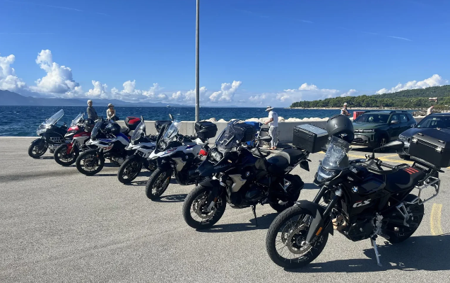

Rent a Motorcycle in Croatia: Ultimate Travel Guide for Two-Wheel Adventures
If you are planning a scenic European getaway, Rent a motorcycle Croatia is one of the best ways to explore the country’s stunning coastline, historic towns, and hidden islands. Croatia offers crystal-clear Adriatic views, winding coastal roads, and charming old cities that are best experienced on a motorcycle where freedom and flexibility meet adventure.
In this guide, you’ll learn everything about Rent a motorcycle Croatia, including how to rent, where to ride, costs, requirements, and the best routes for an unforgettable journey.

Why Choose Rent a Motorcycle Croatia for Your Trip?
Choosing Rent a motorcycle Croatia gives travelers a unique travel experience compared to cars or buses. Croatia’s geography is ideal for motorbike touring, especially along the Dalmatian Coast.
Some key benefits include:
- Freedom to explore remote beaches and villages
- Easy parking in crowded tourist cities like Dubrovnik and Split
- Lower fuel costs compared to cars
- Thrilling riding experience on coastal highways
- Access to scenic mountain and island routes
With Rent a motorcycle Croatia, you can design your own itinerary without depending on public transport schedules.

Best Places for Rent a Motorcycle Croatia Services
When looking for Rent a motorcycle Croatia, you will find rental services in all major tourist destinations:

1. Zagreb
The capital city offers many professional rental companies with a wide selection of bikes—from scooters to high-performance touring motorcycles.

2. Split
Split is one of the most popular hubs for motorcycle rentals because it connects directly to coastal highways and island ferries.

3. Dubrovnik
Known for its historic walls and Adriatic views, Dubrovnik is perfect for scenic rides along the coast.

4. Zadar and Rijeka
These cities also offer affordable Rent a motorcycle Croatia services, often with less tourist crowding and better deals.

Requirements for Rent a Motorcycle Croatia
Before you book your Rent a motorcycle Croatia experience, make sure you meet the following requirements:
- Valid motorcycle driving license (International Driving Permit recommended for non-EU travelers)
- Minimum age requirement (usually 21–25 depending on bike type)
- Passport or valid ID
- Credit card for security deposit
- Basic riding experience for larger motorcycles
Most rental companies also offer helmets, gloves, and insurance options.

Cost of Rent a Motorcycle Croatia
The price for Rent a motorcycle Croatia depends on the bike type, rental duration, and season.
Typical daily rental prices:
- Scooter (50cc–125cc): €20 – €45 per day
- Mid-range motorcycles: €50 – €90 per day
- Touring or premium bikes: €90 – €150+ per day
During peak summer months (June–August), prices may increase due to high demand. Booking early is recommended for better deals.

Best Routes for Motorcycle Travel in Croatia
One of the biggest advantages of Rent a motorcycle Croatia is the incredible road network along the Adriatic Sea.

1. Adriatic Coastal Highway (D8)
This is one of Europe’s most beautiful motorcycle routes, stretching from Rijeka to Dubrovnik. Expect breathtaking sea views, cliffs, and small coastal towns.

2. Split to Makarska Riviera
A short but stunning ride featuring mountain backdrops and turquoise beaches.

3. Dubrovnik to Montenegro Border Ride
Perfect for international riders who want to extend their journey.

4. Island Hopping Routes
Using ferries, riders can explore islands like Hvar, Brač, and Korčula—ideal for a unique Rent a motorcycle Croatia experience.

Safety Tips for Rent a Motorcycle Croatia
Safety is important when enjoying your motorcycle adventure in Croatia. Keep these tips in mind:
- Always wear a helmet and protective gear
- Follow local traffic rules strictly
- Be cautious on coastal curves and mountain roads
- Avoid riding at night on unfamiliar roads
- Check weather conditions before long rides
Croatian roads are generally well-maintained, but winding coastal routes require careful riding.

Best Time for Rent a Motorcycle Croatia
The ideal time for Rent a motorcycle Croatia is between May and September. During this period:
- Weather is warm and sunny
- Roads are dry and safe
- Tourist services are fully operational
- Ferry schedules are frequent for island travel
Spring (May–June) and early autumn (September) are especially recommended for fewer crowds and lower rental prices.

Final Thoughts on Rent a Motorcycle Croatia
Choosing Rent a motorcycle Croatia is more than just transportation—it’s an experience of freedom, nature, and culture combined. From the historic streets of Dubrovnik to the open roads of the Dalmatian Coast, Croatia offers one of the most exciting motorcycle travel experiences in Europe.
Whether you are a solo traveler, couple, or adventure seeker, renting a motorcycle will help you discover hidden gems that most tourists miss.
So gear up, start your engine, and enjoy the ultimate journey with Rent a motorcycle Croatia.

