Cowboys Jerry Jones Upbeat Ahead Of Baltimore Ravens Vs Dallas Cowboys
Short description: Baltimore Ravens Vs Dallas Cowboys in Rio headlines a training camp defined by rare calm, a rebuilt defense and a confident Jerry Jones. Dallas arrived at training camp in Southern California without the usual off-field drama this year. Owner and general manager Jerry Jones, now eighty-three, welcomed the calmer atmosphere heading into camp.
Buy your official Baltimore Ravens Vs Dallas Cowboys Tickets through our trusted platform today to experience the gridiron action live. These highly anticipated regular-season passes are moving incredibly fast on eticketing.co this very moment. Act fast to lock in your preferred stadium seats before they sell out completely.
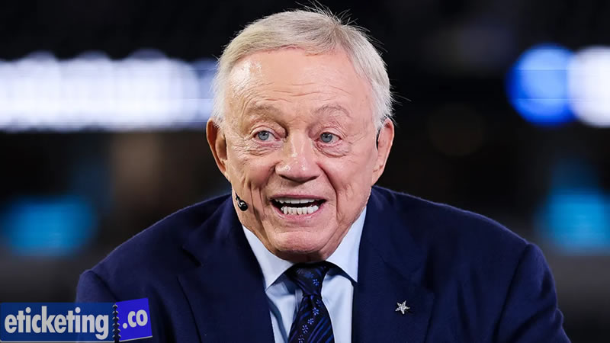
One early-season trip already stands out above every other game on the entire schedule for the entire roster. That trip sends the Cowboys to Rio de Janeiro for a historic Week Three matchup overseas. The Baltimore Ravens vs. Dallas Cowboys game will mark the franchise's first international game in 12 years. Jones said he prefers the perception of a quiet offseason, even if it changes little on the field for the entire organization.
Jones made those comments Tuesday during his annual news conference held right before camp opened. That calm tone contrasts sharply with last year, when a contract standoff dominated headlines all summer. This time, no similar dispute threatens to overshadow preparation for the long international trip to Brazil that lies ahead.

Cowboys Defense Rebuilds Ahead Of Baltimore Ravens Vs Dallas Cowboys
Behind that calm image, Jones admitted his staff scrambled hard to fix a struggling defense. Dallas hired thirty-four-year-old Christian Parker away from the rival Philadelphia Eagles as coordinator. Parker inherits a unit that allowed the most points in franchise history just last season for the year ahead.
Secure your exclusive NFL International Tickets early to watch your favorite gridiron franchises battle on a global stage. The best international stadium seats are available via eticketing.co this very week. Act fast to ensure an unforgettable overseas sports vacation.
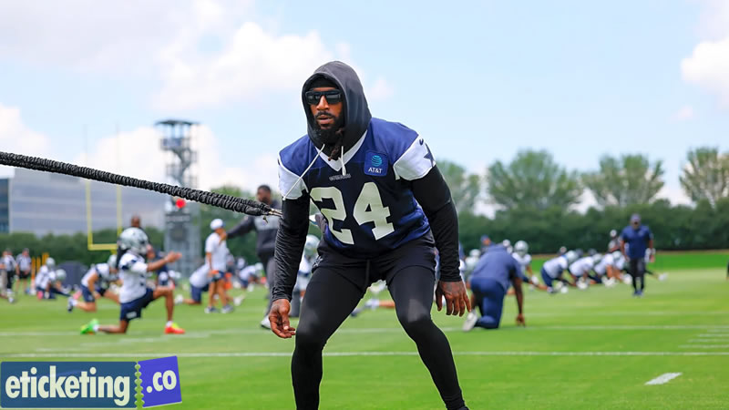
That defense ranked last in the league in both scoring allowed and passing yards surrendered weekly. Fixing those numbers matters even more with the Baltimore Ravens Vs Dallas Cowboys looming early on the calendar. Lamar Jackson and a potent Ravens offense will provide an immediate stress test for this coaching staff.
The Cowboys used their first three draft picks entirely on defensive help this offseason cycle. Ohio State safety Caleb Downs arrived with the eleventh overall selection as a marquee addition. Free agency also further reshaped the entire roster, giving Parker fresh pieces before that historic season-opening trip to Brazil begins.

Cowboys Offense Prepares For Baltimore Ravens Vs Dallas Cowboys
Dallas still enters camp with real offensive firepower no matter how the defense performs. Quarterback Dak Prescott leads a group featuring wide receivers CeeDee Lamb and George Pickens together. That trio gives coach Brian Schottenheimer a dynamic foundation heading into a demanding early-season slate for the entire season ahead.
Grab your NFL Rio De Janeiro 2026 Tickets directly from eticketing.co to witness an unprecedented historic sports showcase in South America. Experience iconic stadium energy and electric international crowds firsthand. Do not hesitate for a single second; lock in your official game passes today before prices jump!
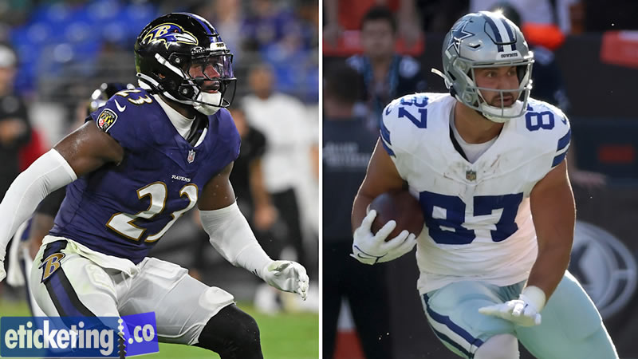
Prescott and Lamar Jackson will renew a notable rivalry when Baltimore Ravens Vs Dallas Cowboys kicks off. Jackson won league MVP honors in 2023, the same year Prescott finished as runner-up. That storyline alone gives the Rio matchup extra weight beyond its international novelty for both storied franchises involved.
Prescott reportedly arrived at camp wearing a shirt celebrating the franchise's last championship season from 1995. That symbolic gesture reflects genuine belief that this roster can compete at a higher level. Jones said he genuinely appreciated hearing that kind of positive optimism directly from his own starting quarterback this summer.

Baltimore Ravens Vs Dallas Cowboys Tests A Retooled Roster
Getting the retooled defense ready alongside that offense remains the central challenge before the Rio trip. Dallas hopes strong complementary football can finally end a three-year absence from the postseason. How quickly Parker's unit progresses could shape how the Baltimore Ravens Vs Dallas Cowboys unfolds this entire upcoming season ahead.
Claim your Ravens Vs Cowboys Tickets at this very moment to experience one of the most intense high-stakes rivalries on the gridiron. Dedicated fans can easily secure Baltimore Ravens Vs Dallas Cowboys Tickets via eticketing.co today. Act fast and reserve your seats now to enjoy every thrilling snap live!
The ten-hour flight home from Brazil adds a unique wrinkle to an already very demanding early-season slate. Dallas plays Houston just days after returning from Rio, leaving little time to recover fully. Prescott has already flagged sleep management as a genuine concern heading into that demanding early stretch.
Dallas finished last season with a modest seven-win-nine-loss and one-tie record. Still, the Cowboys went six and one with one tie whenever they scored thirty points. Schottenheimer called it a great offseason internally, regardless of outside perception heading into the season ahead for the entire roster.

Cowboys Could Make More Moves Before Baltimore Ravens Vs Dallas Cowboys
Jones acknowledged the offseason felt anything but quiet internally, even though it looked calm publicly. New scheme, new coaches and new players all arrived within a compressed and demanding timeline. He said he has fully bought into that rebuilding process moving into the new season for the entire upcoming season.
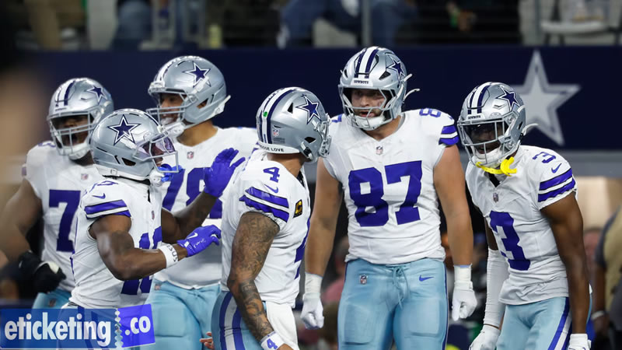
Jones did not rule out making further roster moves before or during the regular season. He mentioned recent contact with another NFL owner regarding a possible trade for added depth. Details remained scarce, though the comment suggests Dallas stays open to upgrading its roster further throughout that entire long stretch.
He declined to address specific interest in a prominent Las Vegas Raiders pass rusher, citing tampering rules. A separate trade sending that player to Baltimore fell apart earlier this year over a physical. That irony was not lost on reporters given the upcoming Baltimore Ravens Vs Dallas Cowboys matchup for the entire fan base.
Get your premium NFL 2026 Tickets right now to guarantee your spot at the biggest football events of the year. Football enthusiasts are already rushing to eticketing.co to secure their entry. Do not wait until the last minute for these elite stadium passes.

Frequently Asked Questions

When do the Cowboys play the Ravens in 2026?
The Cowboys face the Ravens in Week Three, on September 27 in Rio de Janeiro, marking Dallas's first international game in twelve years.

Who is the Cowboys' new defensive coordinator?
Christian Parker, previously with the Philadelphia Eagles, now leads a defense that ranked last in the league in scoring and passing yards allowed last season.

Why is the Cowboys' offseason considered calmer this year?
Unlike last year's contract standoff that ended in a trade, Dallas has avoided any major financial disputes heading into training camp this summer.

Who are the Cowboys' top offensive players this season?
Quarterback Dak Prescott leads an offense featuring wide receivers CeeDee Lamb and George Pickens under head coach Brian Schottenheimer.

Could the Cowboys still make more roster moves?
Yes. Jerry Jones has not ruled out additional trades and confirmed recent contact with another NFL owner about potential help.

